Replication in SQL Server:

I have two instances (server) as below in my local system.

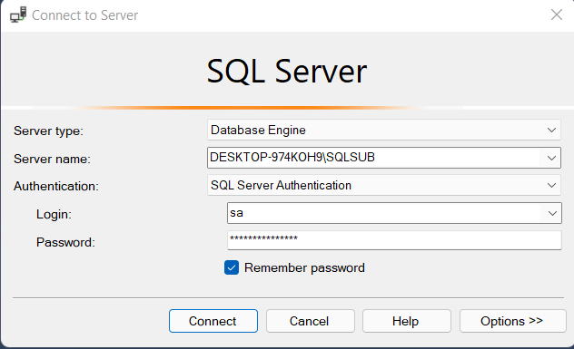

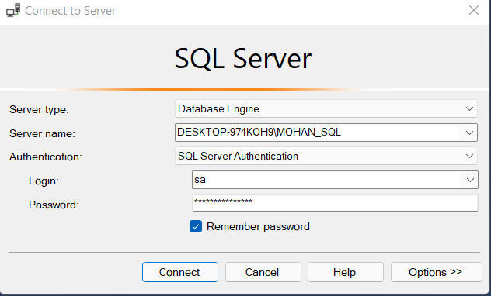

Configure Distribution:

**Step1:** Right Click on Replication and click on Configure Distribution.

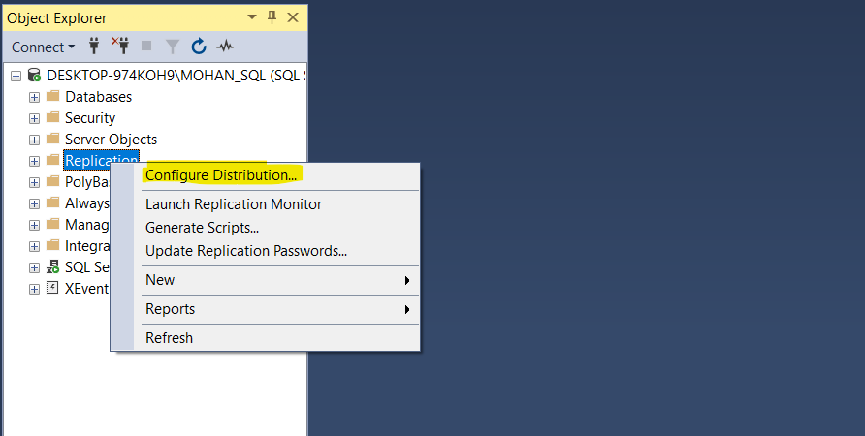

**Step2:** It may show below pop-up just click on next

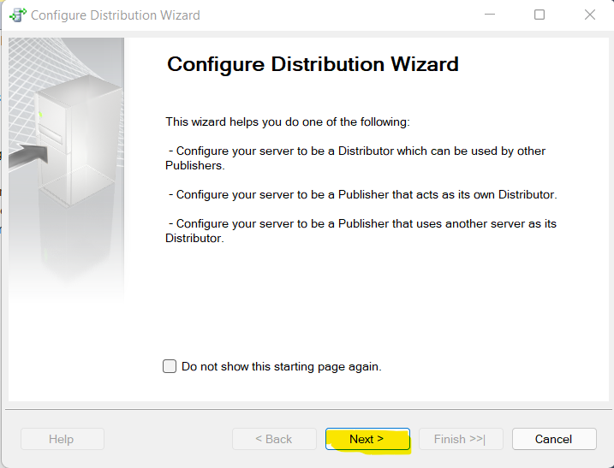

**Step3:** Select the default and click on next

**Note:** we can give different server name (configure different server) by selecting second option.

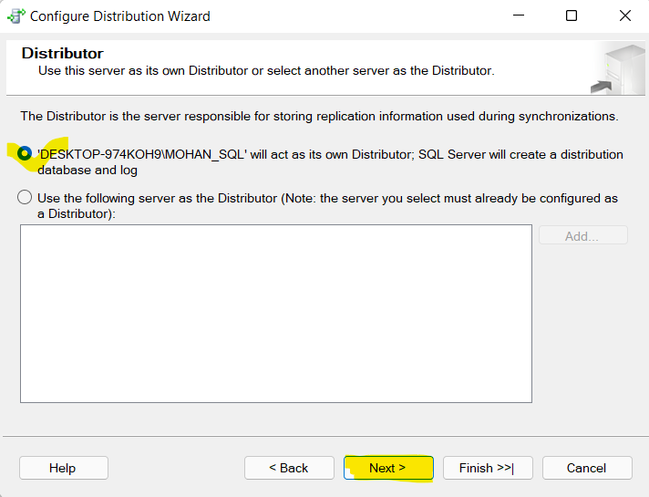

**Step4:** Give the path or let it be the default path but I have given shared path (network path).

In my Case I am giving default path only (as I faced an issue previously).

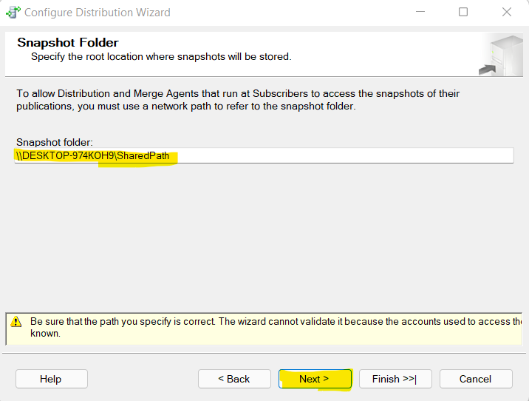

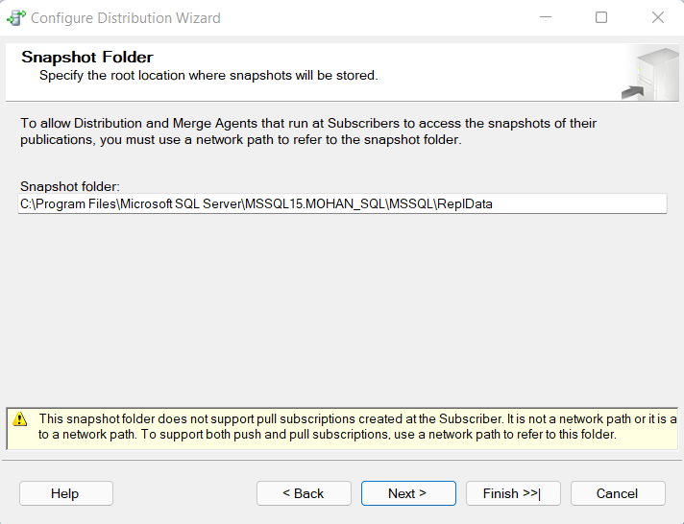

**Step5:** distribution database name and path (default) we can give. We can change the path but as of now I kept default path.

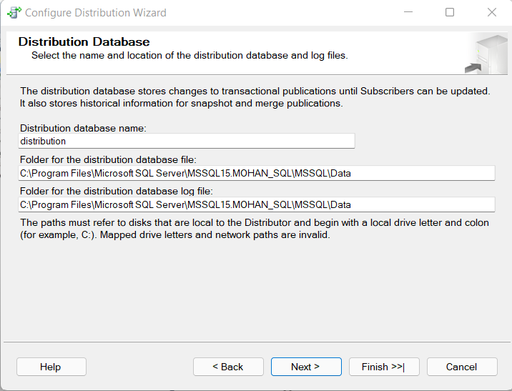

**Step6:** Select the publisher and click on next.

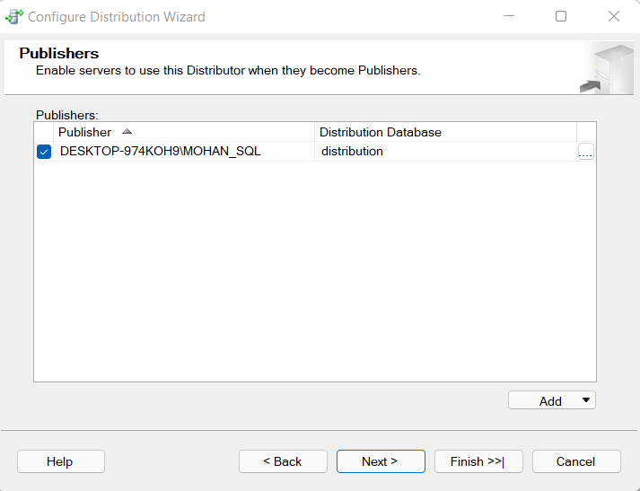

**Step7:** At the end of the wizard, select configure distribution.

We may select both options so it will generate the SQL script.

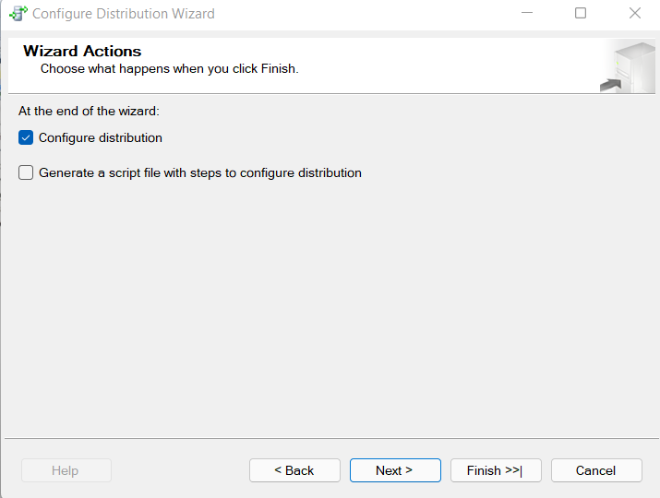

**Step8:** Verify the wizard and click finish.

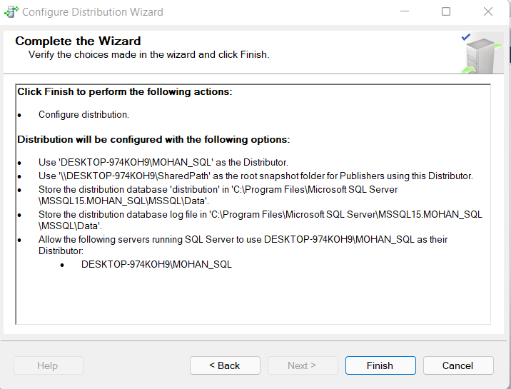

**Step9:** Once it is success, if you want to “Save Report to File” then click on Report=> Save Report to File else click on close.

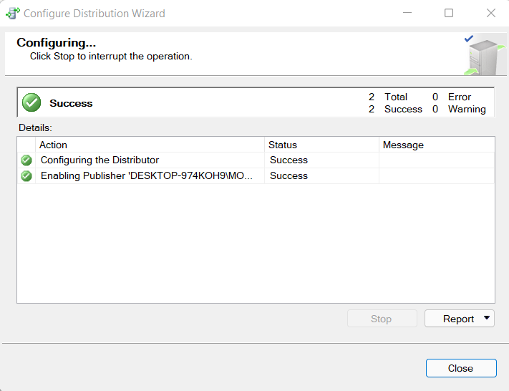

Now Distribution is configured.

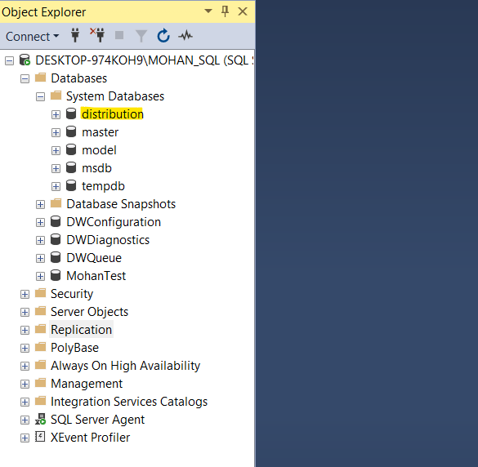

**Step10:** Now right click on Replication=> New=> Publication

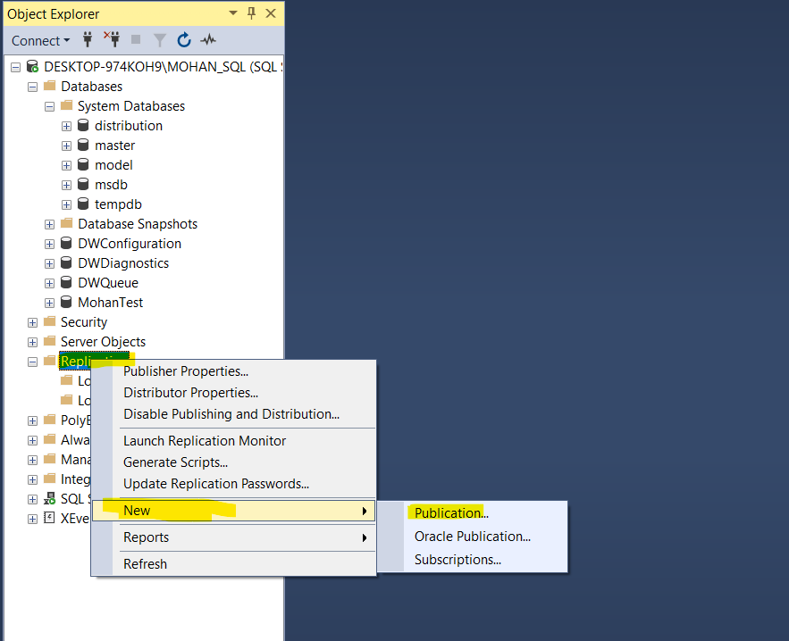

**Step11:** It will open a new publication wizard, just click on next.

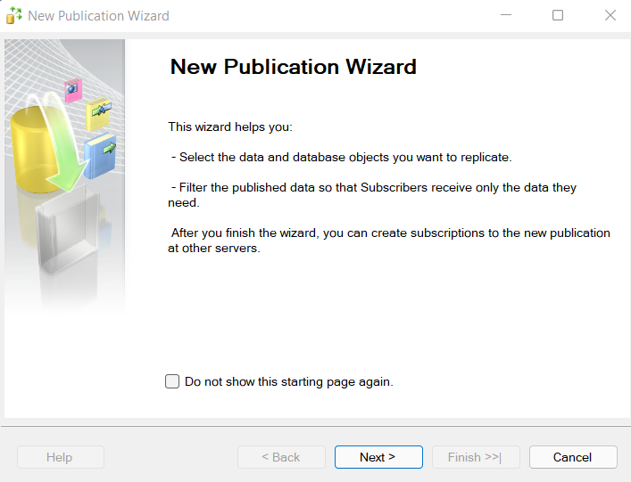

**Step12:** Select the database that you want to replicate.

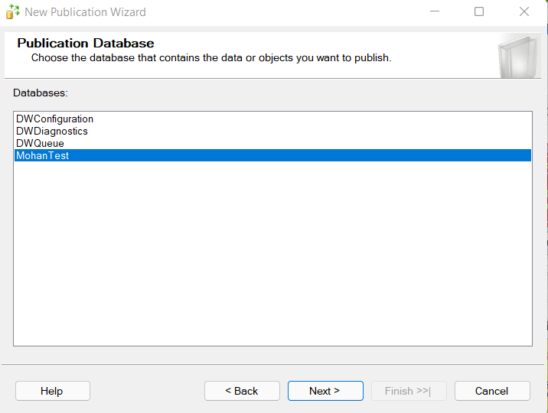

**Step13:** Select Transactional replication and click next.

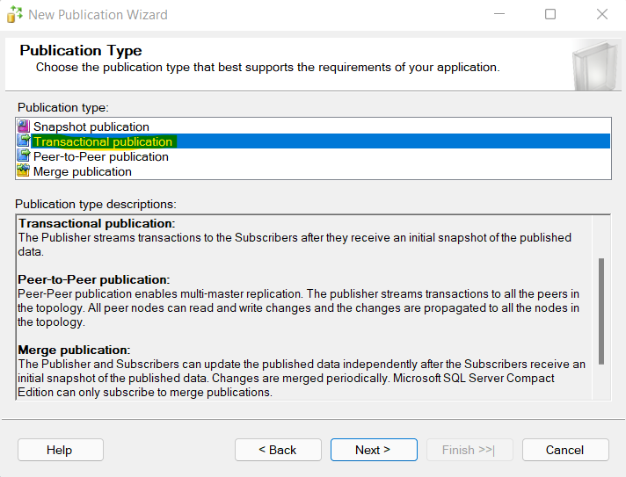

**Step14:** Now we need to select the objects as shown below click next.

Note: table who has primary key only you will be able to select, if a table doesn’t have primary key then you cannot select that table and it will be as cross mark (table **tblTest**).

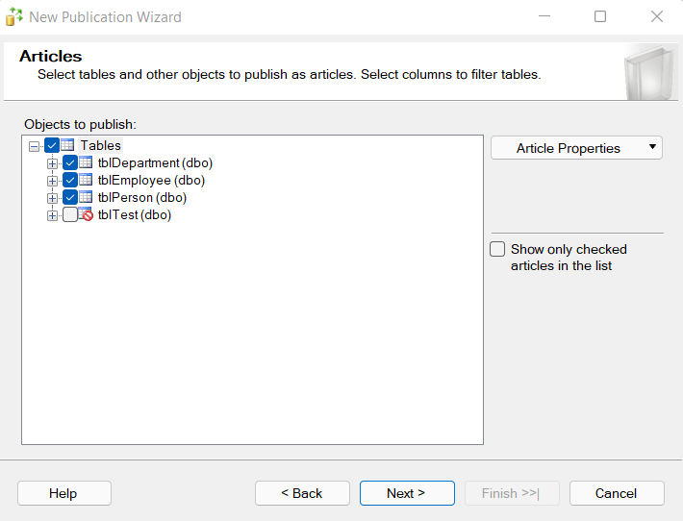

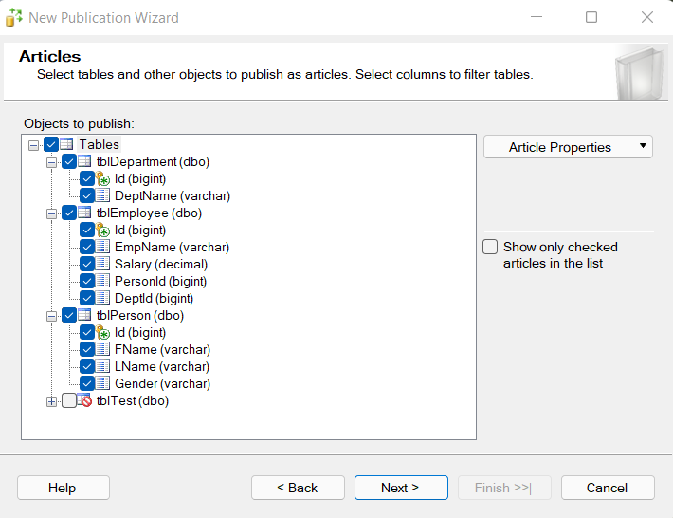

**Step15:** window will appear as below and wecan click on Add so we can exclude the columns to replicate, we can select only replicate column name also.

As of now I am not going with this option so just click cancel for second screen the click on next in first screen.

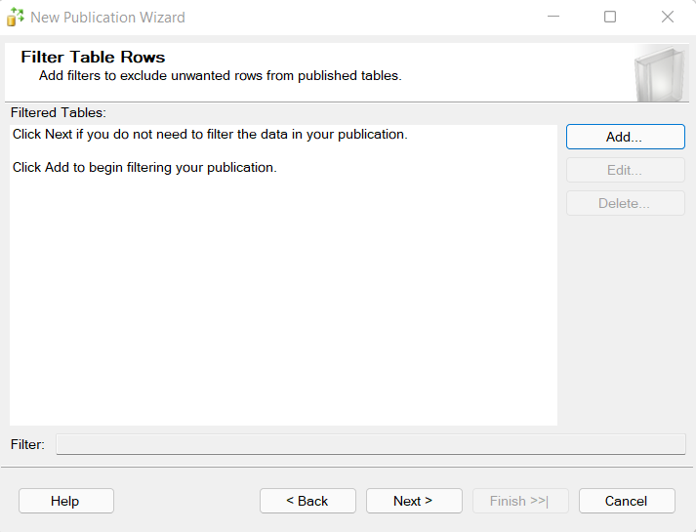

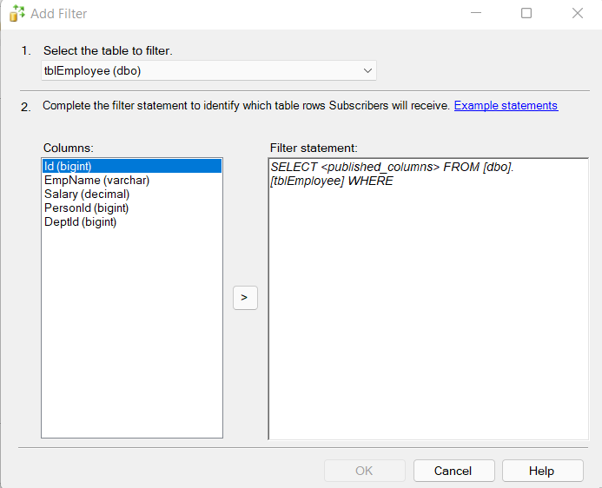

**Step16:** There are two option when to run snapshot agent, I am going with first option as shown below.

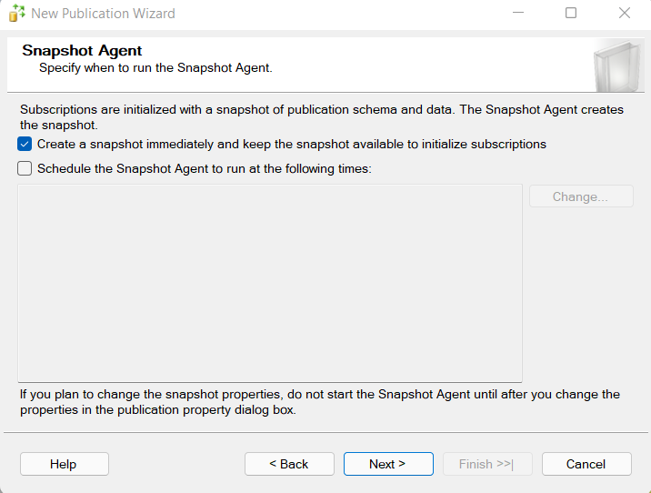

**Step17:** Agent Security will open, click on security setting and give the process account and password, as of now I am connected with local so giving local account only.

**Note:** Need to give Window user and Window password not SQL server user (sa) and password.

To get the username (window users) open CMD and run below command.

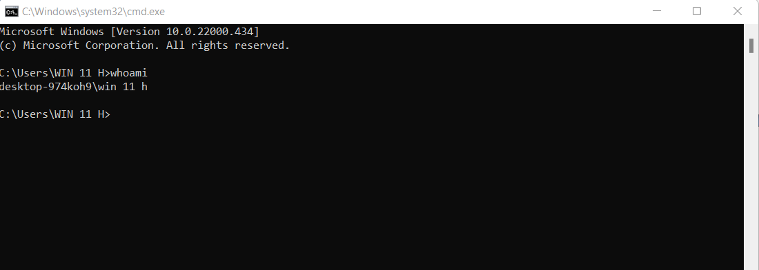

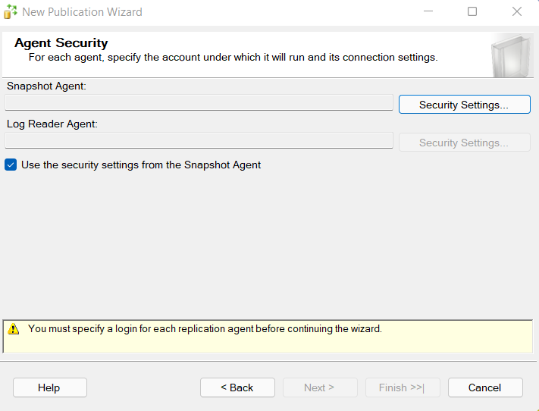

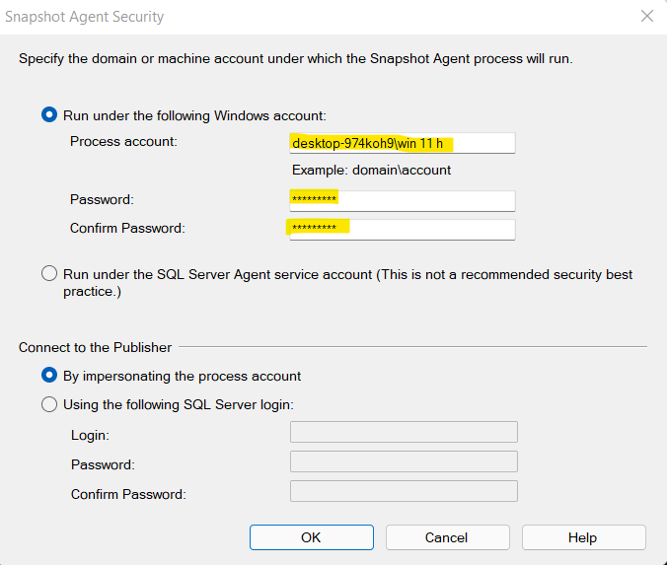

Or we can select second option as below, click next.

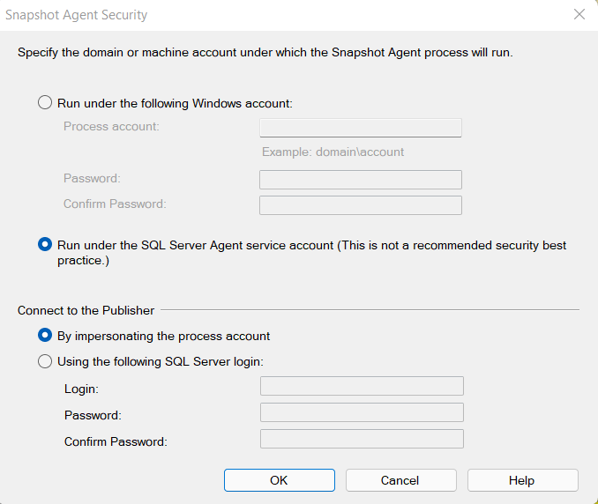

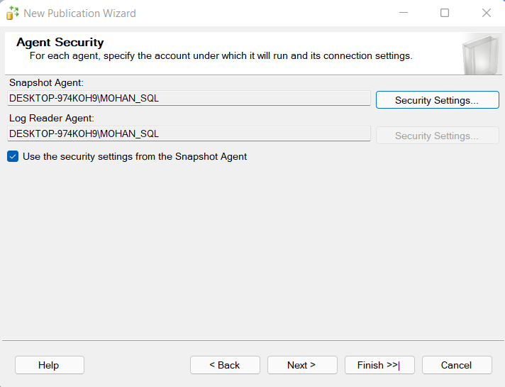

**Step18:** We can create the publication and same time we can generate the script as well if we check second option from below screenshot. Click next

If we select both the options then you have to give path as second screenshot.

C:\Users\WIN 11 H\OneDrive\Documents\CreatePublication.sql

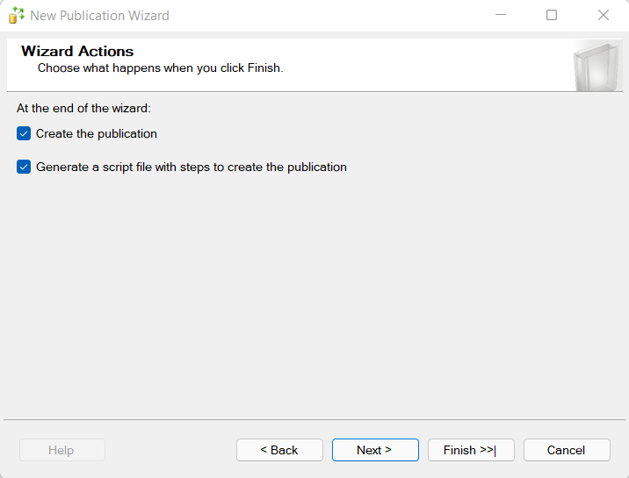

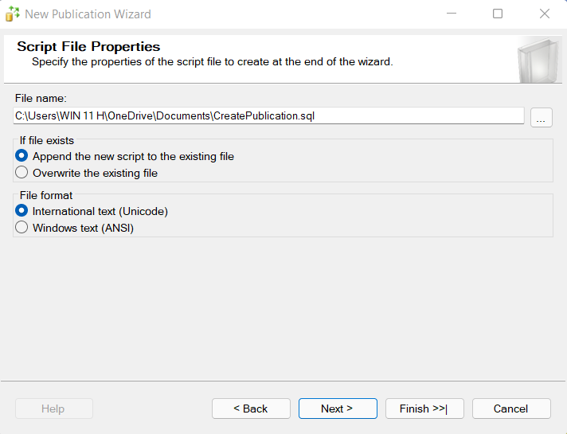

**Step19:** Verify the publication wizard and give publication name click next and then click closed.

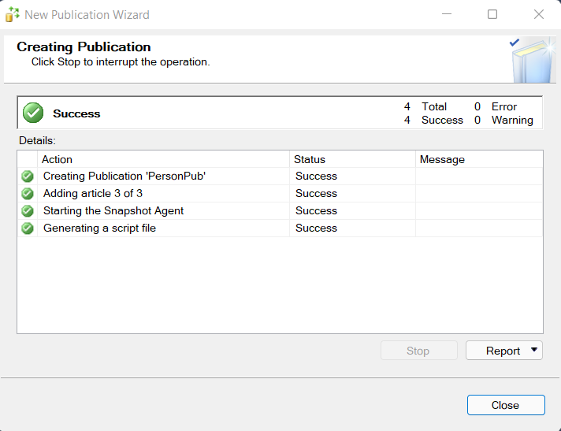

**Step20:** Now go to second server.

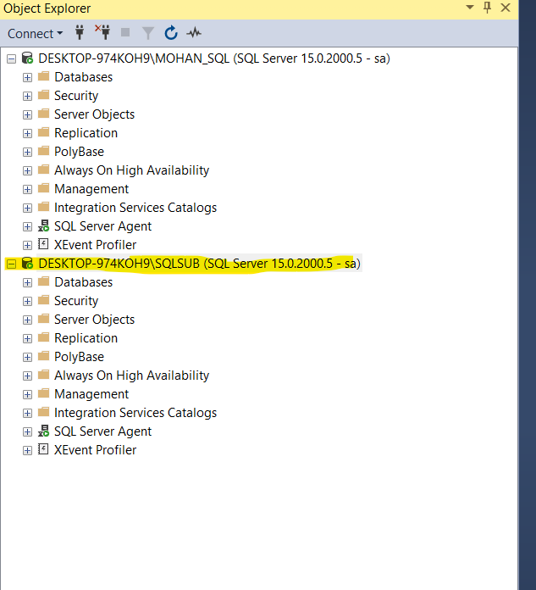

**Step21:** Now we need to configure the Subscriber in second server, right click on Replication => New => Subscriptions as shown below.

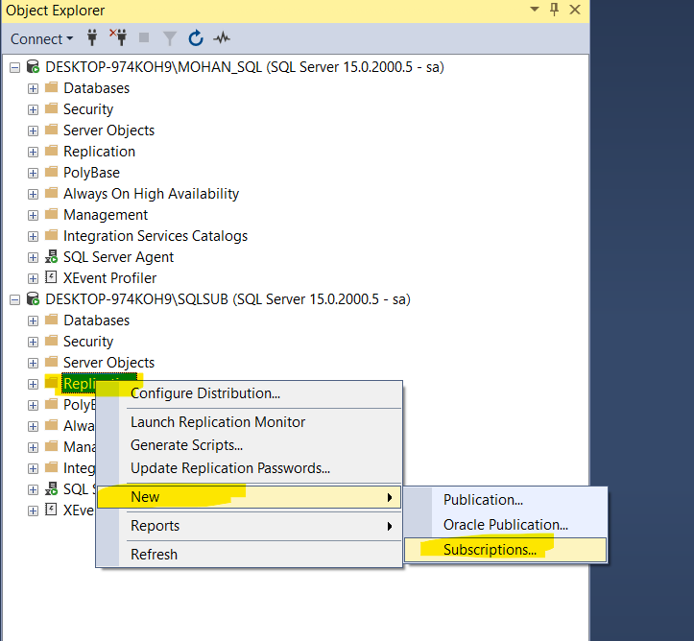

**Step22:** It will open Subscription wizard as shown below, click next.

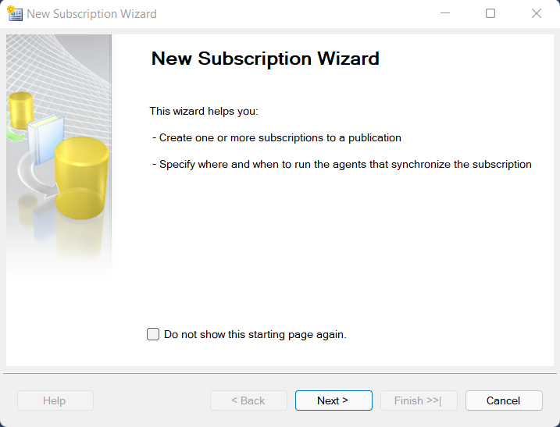

**Step23:** Now you have to select your publisher, and by default your publisher (publication name will appear and selected).

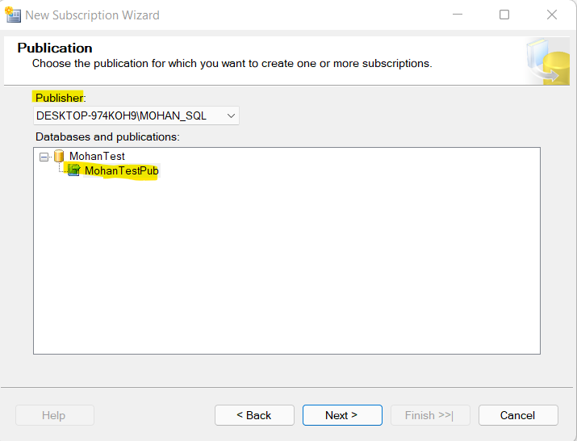

**Step24:** Here Push Subscription and Pull Subscription window will appear, I am going with default selection.

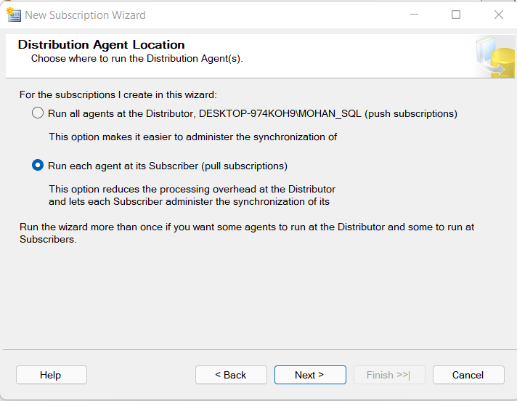

**Step25:** Here if you have already database then we can proceed with that, as of now I don’t have database in Subscriber server so I will create a new database

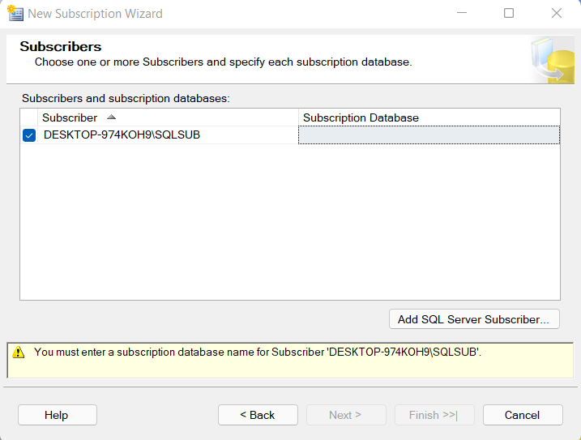

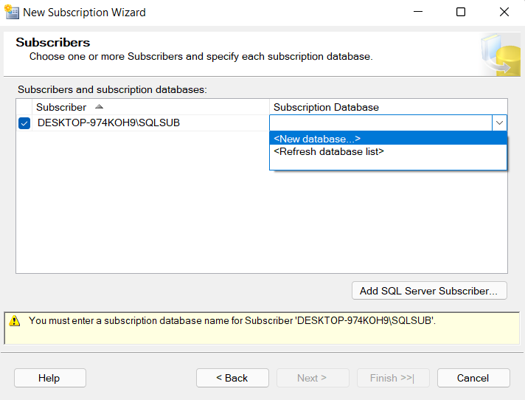

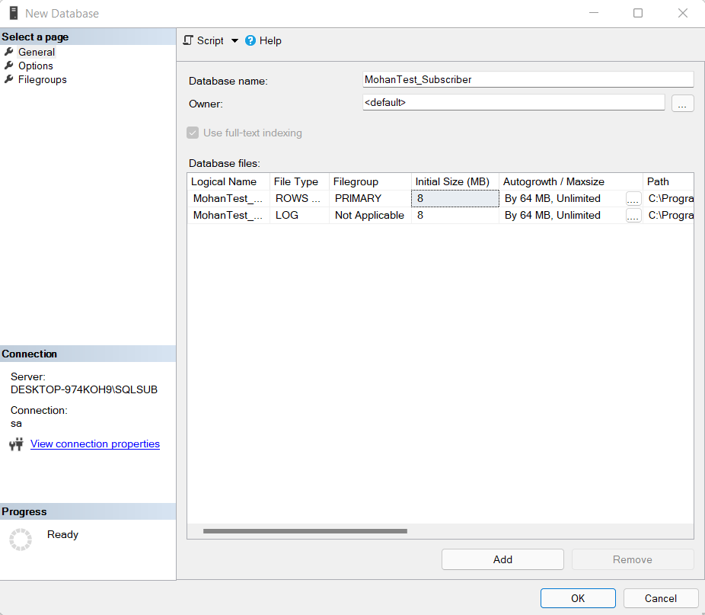

**Step26:** Once database is selected then click on next.

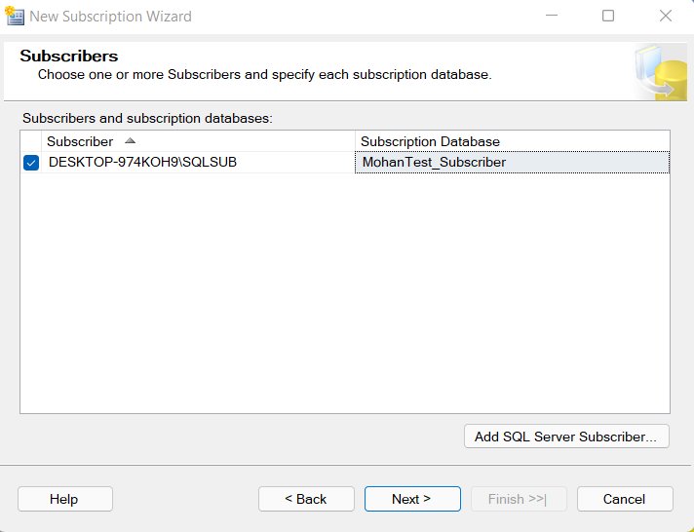

**Step27:** Next Distribution security agency window will open as below, click right side three dots.

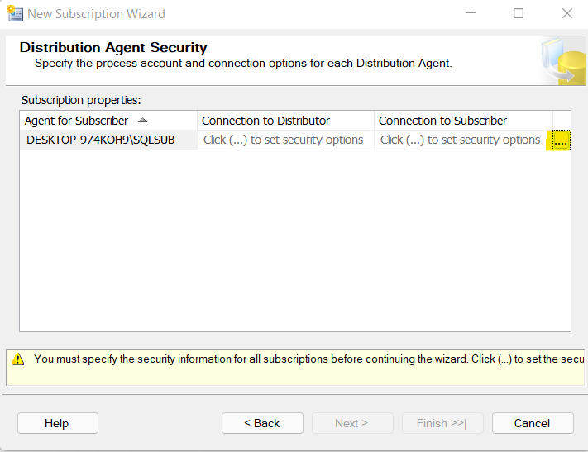

**Step28:** It will open a new window; we can give process account and click ok.

I am choosing second option in my case.

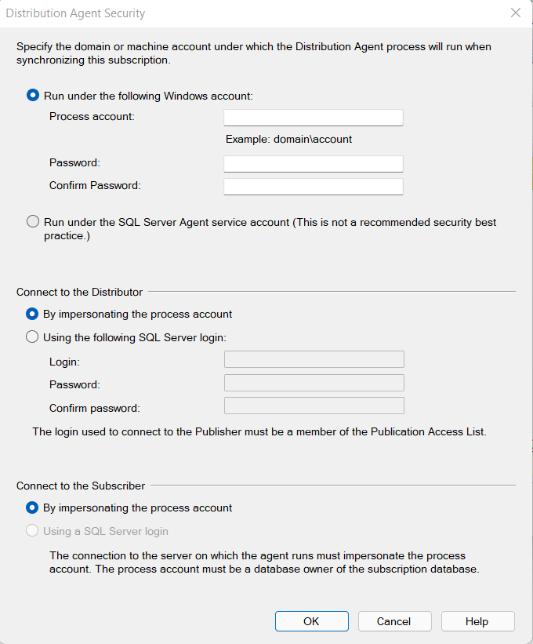

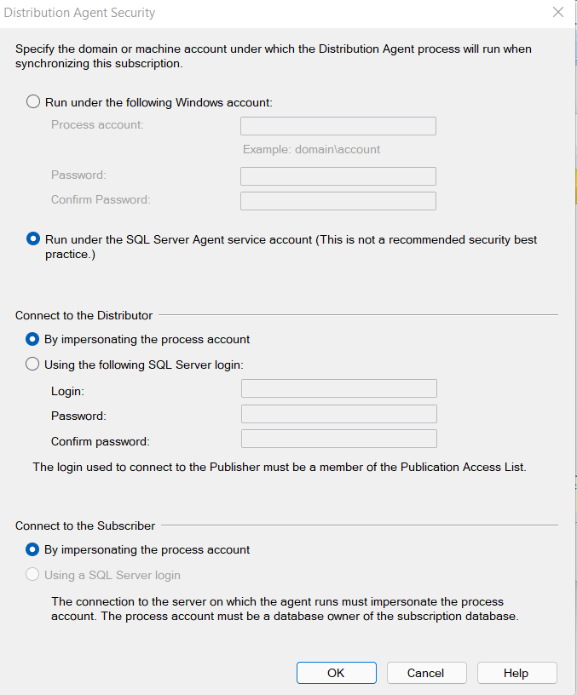

**Step29:** Below window will appear, just click on next

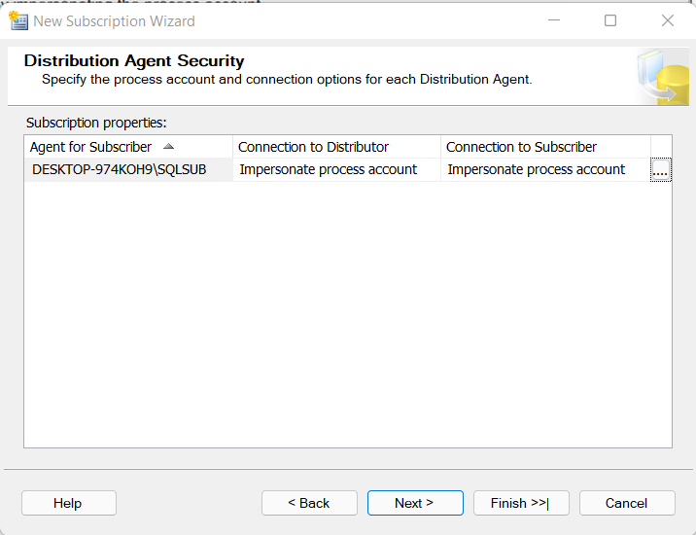

**Step30:** Below window, we can configure the agent schedule. As of now I am going to use default.

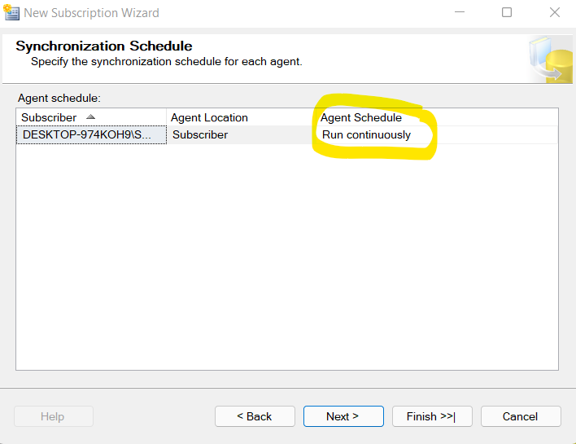

**Step31:** Below window, we can select Initialize when, as of now I am going with default.

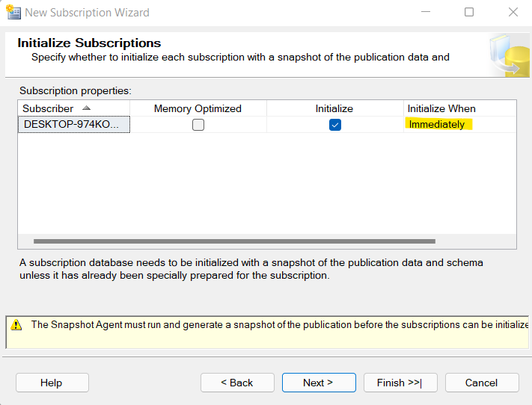

**Step32:** Below window, we can select create subscription.

**Note:** If we need script we can select second option as well.

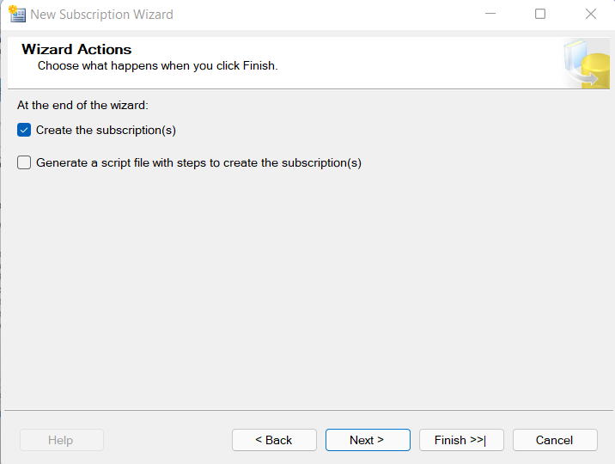

**Step33:** Verify the entire wizard, and click on finish.

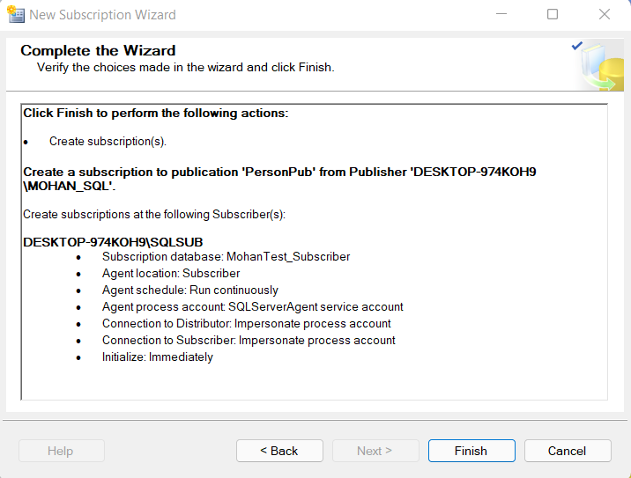

**Step33:** Below window shows subscription created successfully. Click on close.

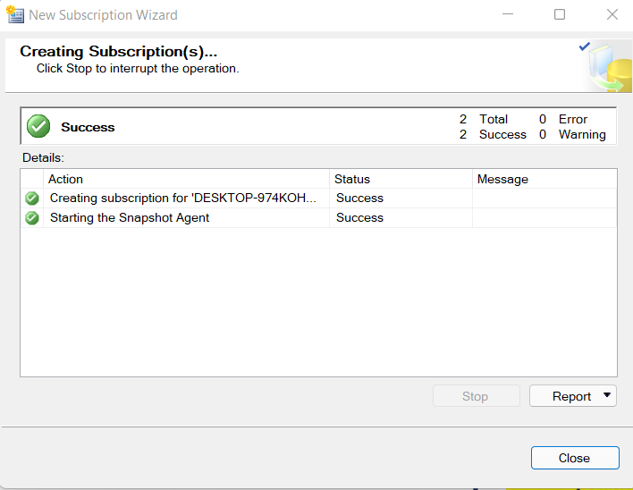

**Step34:** Go first server, and click on Replication => Launch Replication Monitor.

We could see replication is working fine.

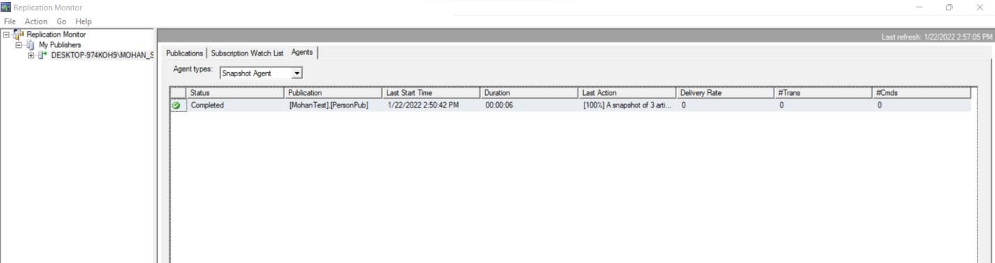

All tables are reflected in Subscriber database as below.

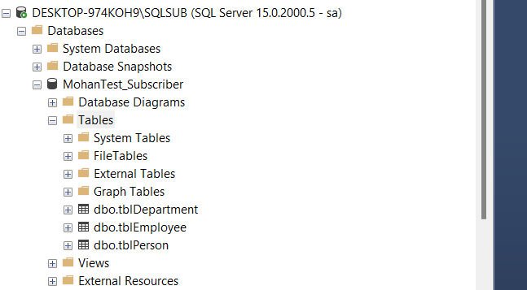

**Step35:** Now if we check and run below query in publisher and subscriber then both are empty.

**Query:** select * from tblPerson;

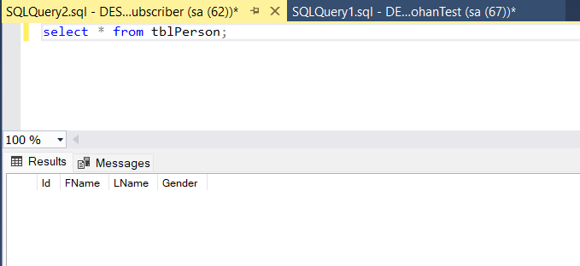

**Step36:** Now we will insert a record in our publisher database and see if same record reflects in our subscriber database as well.

**Query:** insert into tblPerson values ('Mohan','Chandra','Male');

Now if we verify the data in both the database (publisher and subscriber) it is available in both the database.

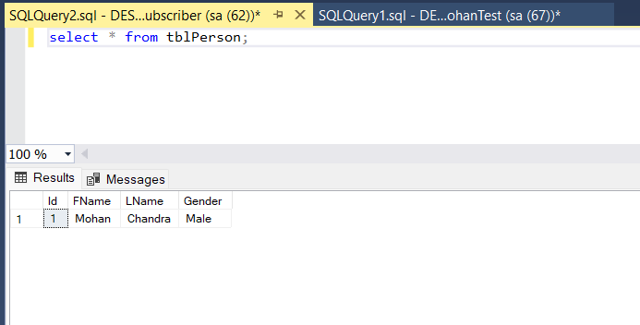

So like this we can configure the replication in SQL server.

Happy Learning.